The Judges’ Guide

Thank you for agreeing to be a judge for the GSMA’s Global Mobile Awards 2024 programme. To help you understand how the judging process works we have produced this guide. We hope you find it helpful.

Getting Started

Judging is completed on-line using the secure GSMA Judging portal. The password and link to the Judging website will be within the email you receive during the w/c 4th December 2023 from awards@mwcbarcelona.com. The subject line of the email is “Welcome to Global Mobile Awards– Judge Access Granted”. Please note all emails from awards@mwcbarcelona.com will be sent to the email address that CCgroup has been using to communicate with you. Please ensure you check that email address for the password and link sent on w/c 4th December 2023.

The link within the email will take you to the Judging portal. On the top left, you will need to enter your email address, and the password you have been sent. You will then be given the option to change your password, and you will receive a confirmation email if you choose to do this.

The Judges’ Section

Once you log in, you will be directed to the main page where you will see a link that you can click on if you wish to obtain a pass for MWC Barcelona 2024.

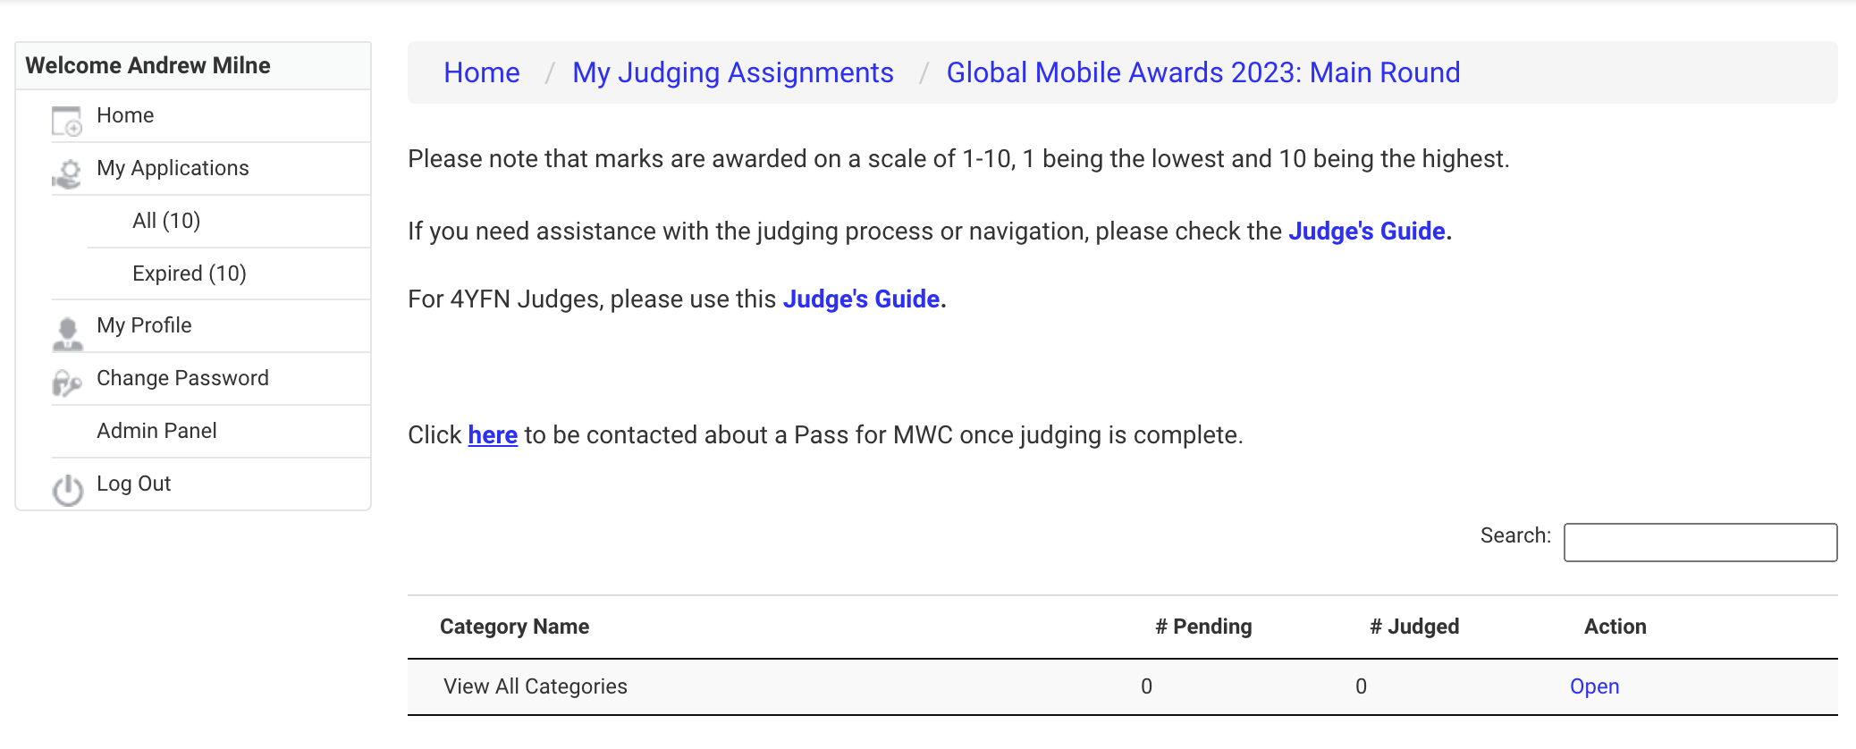

Within the Judging portal, you will only be able to access the category or categories that you have been asked to judge.

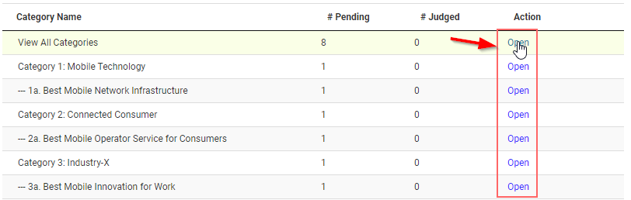

In some circumstances where the number of entries in a category is very high, we will split the category between the judges to make the workload manageable for you. You will already have been informed if you are judging a split category.. If you are judging a split category, it will be clear to you when you enter the site which entries you need to judge and mark.

When you click on ‘Open’ to the right of the category name, you will see all the entries within the category. You can choose to download all entries as a PDF – See highlight below.

At the top you will see that you can sort the entries by score or alphabetically, you can also see your scores per entry, how many entries you have scored and how many you have left to score.

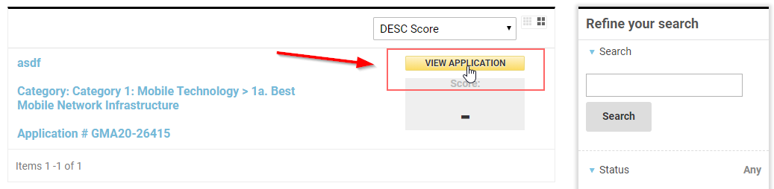

To open each individual entry, you can either click on ‘VIEW APPLICATION’ or on the entry heading.

Once opened, you can see the applicant detail and category detail. You can now access the full eligibility for each category within the entry submission itself. This makes it easy to refer to if you have any concerns. Remaining tabs are for the supporting materials and category questions for scoring.

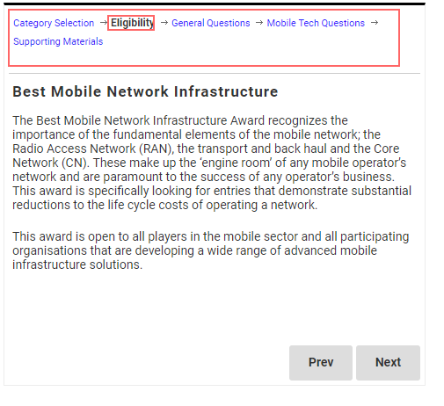

Once you have opened an entry, you will see that you can also choose to download each individual entry as a PDF – See highlight below.

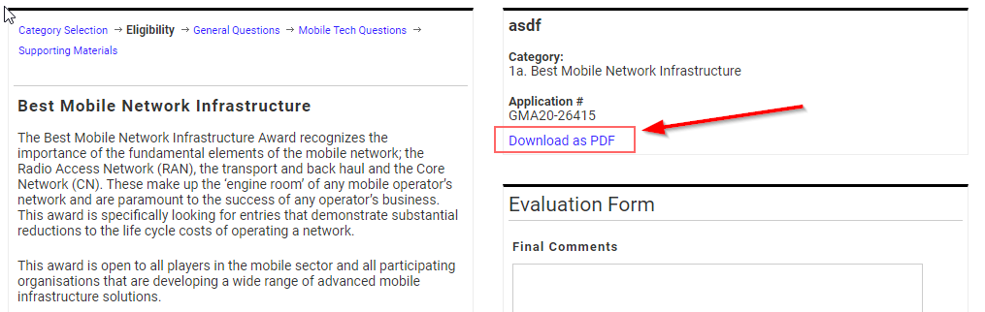

If at any time you need to see the status of your judging, simply click on the ‘My Judging Assignments’ link, and you will see your list of assigned entries. You will see two columns to the right of each entry, showing the status as either #Pending or #Judged. Before you begin, all entries will be listed as “#Pending”, once you have finished all aspects of judging, and saved your scores, all entries will list as “#Judged”.

Once in the entry, you will also see the entry name, the Evaluation Form (Final Comments) on the right and the Shared Judge Comments box underneath (seepage 9).

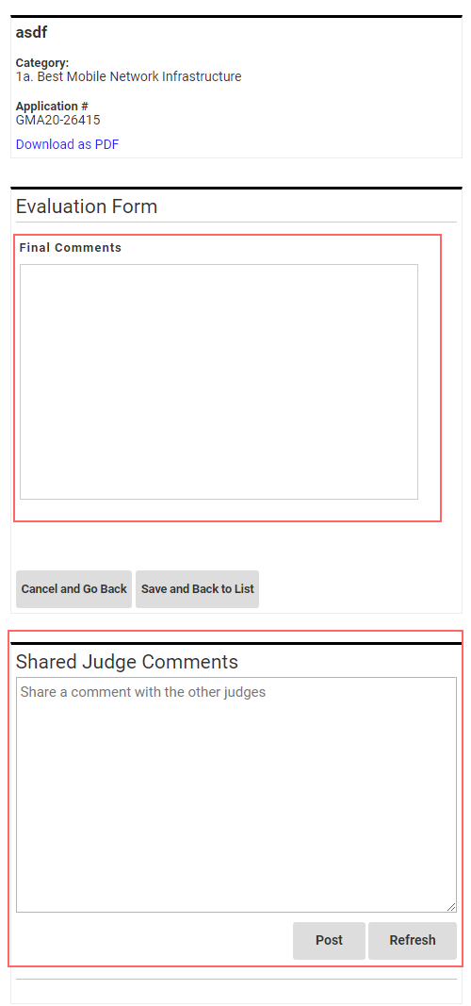

You can navigate using the bar along the top of the page, see below.

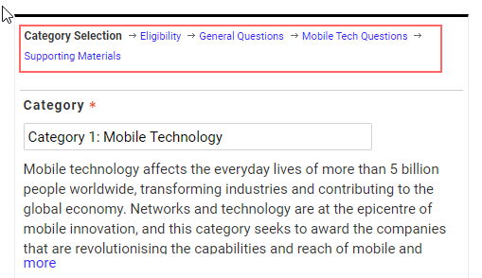

The next page after the eligibility section – see screenshot below for example - is the ‘Supporting Materials’ section. We encourage entrants to make use of multimedia, and this section may contain links to short videos. These videos will help give judges a better first impression of the entry and we hope that entrants will have taken this opportunity to help convince the judges as to why their entry is the best.

There is also an area where entrants can add URLs, documents or apps to better illustrate the strength of the entry. Please take the time to study these supporting materials prior to making your final scores.

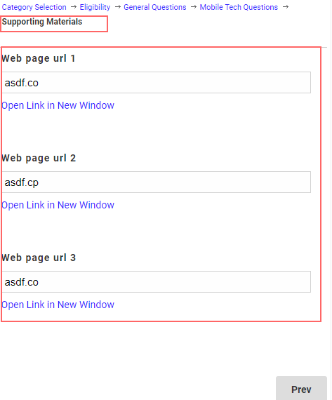

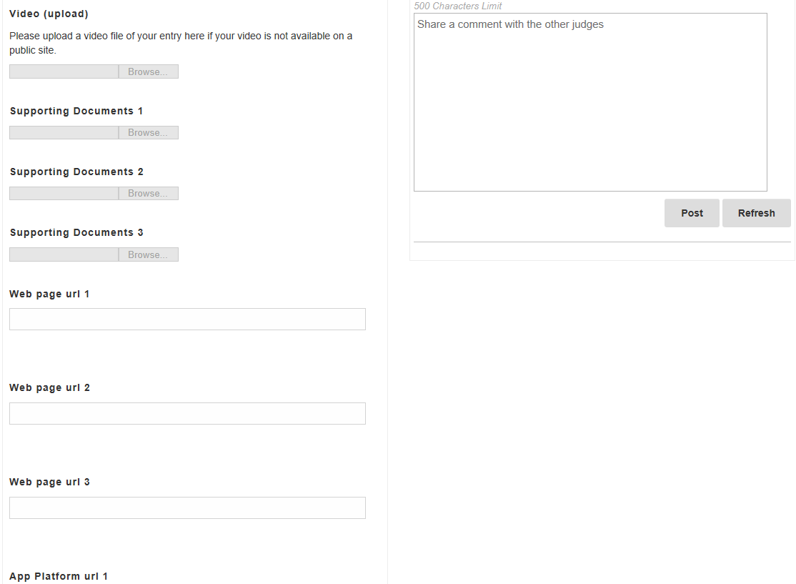

The next page includes the category questions, and the answers to those category questions. Please note only some answers require you to score, others are for information only. Marks are awarded on the scale of 1 – 10, 1 being lowest and 10 being highest, using the dropdown scoring boxes.

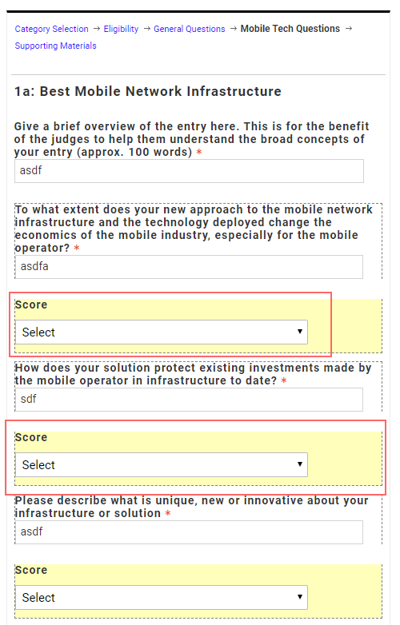

Using the Final Comments form on the right hand column of each entry, we would ask that you add any comments you may have in the box provided. This is optional but it will help us greatly if you tell us why you rated a particular entrant highest. In fact, if you do this for your personal top five in the category, it will help us in the case of tied scores. We also use these comments at the announcement of the Awards winners at MWC in Barcelona. Comments in the Evaluation Form are also used to help decide if an entry should be Highly Commended – effectively a ‘runner-up’.

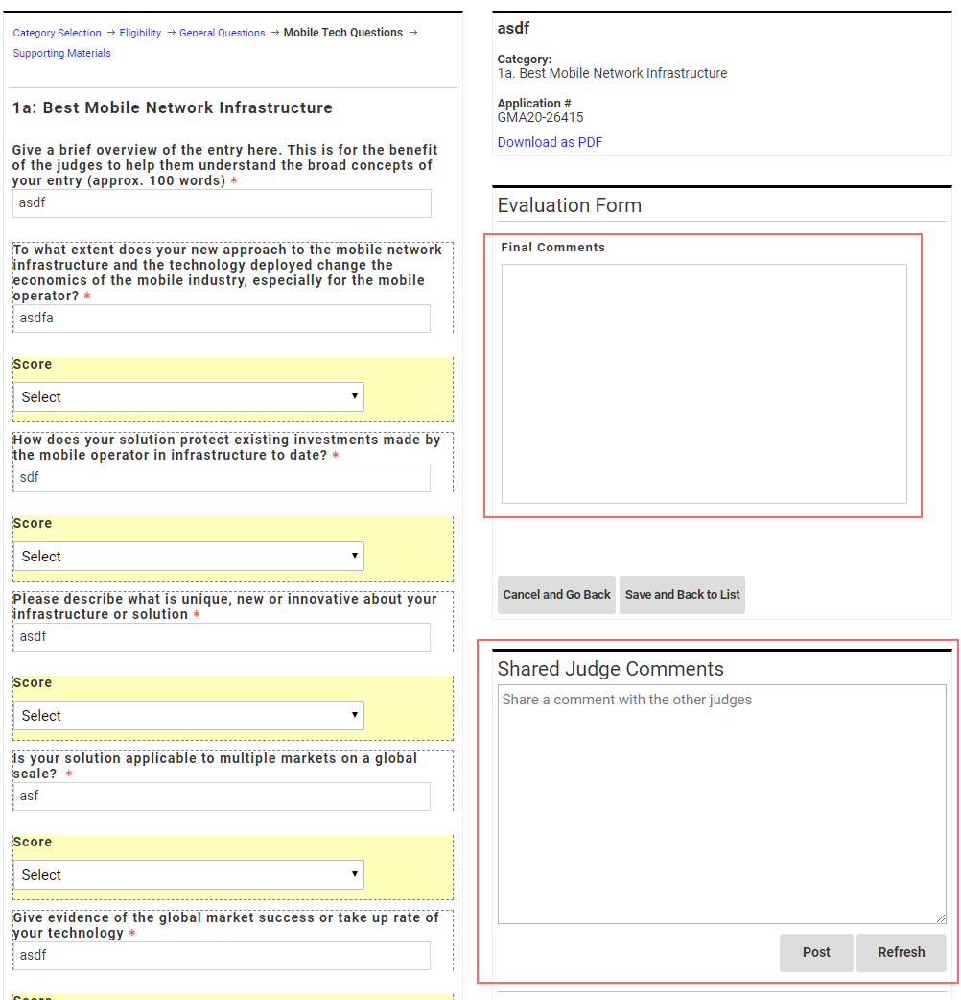

Any comments you make will be strictly confidential and although they may be used in the public domain, will only be attributed to ‘The Awards Judges’.

You may also make comments as you move through the entries. The box underneath is the Shared Judge Comments, where other judges in your category can see your comments, and you can see theirs. This is your own private category chat room for you to post comments, ask questions of your fellow judges or share opinions and knowledge about an entry that you think might be helpful to other judges. Nothing from this chat room will ever be published but please be aware that there is no delete / edit option.

To reconfirm, the Evaluation Form, is for your own final comments on the entry – only you will be able to see those comments, and these may be used for promotional purposes as previously described.

Before you begin to judge, please ensure that you review each entry against the entry eligibility, to ensure the entry meets the stated requirements. You can access by clicking on the Eligibility tab along the top of each page in the submission.

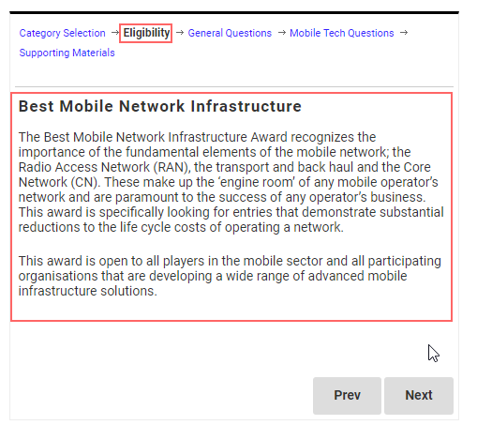

If you feel an entry does not meet the eligibility, please contact Shaun Collins, the Chair of Judges, with your concerns (contact details at the end of this document).

In relation to finalising the judging on any entry, there are three options at the bottom of the entry page.

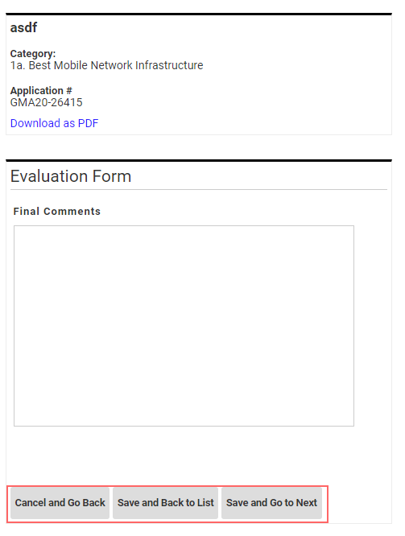

Cancel and Go Back = If you are taking a first look through the entry and are not ready to score it yet, you can click on Cancel and Go Back and leave the entry.

Save and Back to List = If you judge and complete the scoring on an entry, you need to click on “Save and Back to List”. This will save the scores on the entry and bring you back to the list of entries. You cannot “Save” an entry unless you have scored all the required questions, so the system will not allow individual entries to be saved until scoring has been completed.

However, you can go back and revise your scores on saved entries at any time until judging closes.

Save and Go to Next = Save your scores for that entry and move to the next entry.

You will not be able to view other judges’ scores.

Judging tips

- Plan your time.
- Start early, get ahead of the game.
- Remember to save your work at the end of each session.
- Do it in short(ish) sharp bursts.

Please remember to study the entry eligibility and ensure that each entry meets the criteria before you begin your evaluation. If you feel an entry does not meet the eligibility, please contact Shaun Collins, the Chair of Judges (contact details at the end of this document).

Remember your industry knowledge is why you have been invited to judge.

What to look for in judging:
Stand out entrants, entrants that are truly innovative, clever, different, and smart.
Use your industry knowledge and experience. Your expert opinion is what matters.

Please do not mark an entry if you have any connection with or a conflict of interest with the entrant. If any conflict should arise, please let Shaun or Awards Administrator Beth Sharples know (contact details at the end of this document) so that we can arrange for the entry to be judged independently.

It is very important to keep all aspects of the judging strictly confidential. Please don’t discuss any aspect of your judging with anyone else other than your fellow category judges. In some instances, however, you may want to consult with a colleague who may have specialist knowledge or expertise in the area of a particular entry. This is allowed, but please convey the need for confidentiality to your colleague.

Regarding social media, you may of course promote that you are a judge, but please do not post about individual entries.

We are aware that in our busy lives sometimes unforeseen circumstances can arise and disrupt our diaries. If you feel at any stage that you may not have time to complete judging all the entrants in each category, please let us know as soon as possible.

When Judging Finishes

After the judging finishes, the aggregated scores will produce the top five submissions. The submission with the highest score wins. We will communicate the short list of five, and the winner, in each category back to each set of category judges.

If you are judging a split category, the slightly different process will be explained before judging commences.

It is very important to maintain secrecy on the results. The shortlists are not made public until 5th February 2024, and the winners are not announced until MWC Barcelona (26th February – 29th February 2024).

Log in details issued: 4th December 2023

Judging begins: 5th December 2023

Round 1: Judging Closes for Split categories ONLY 10th January 2024 (12noon GMT)

Round 2: Judging begins for Split categories ONLY 15th January 2024

Online scoring for all categories must be complete by 22nd January 2024 (5pm GMT)

Shortlist Published 5th February 2024

MWC Barcelona 2024 26th February – 29th 2024

2024 GLOMO Awards Ceremony Tuesday 27th February 2024

Other Awards presented during MWC Schedule to be finalised

Throughout the process, please feel free to contact either of us if you have any questions or need any help.

Shaun Collins, Chair of Judges
shaun.collins@ccsinsight.com +44 7836 699970

Beth Sharples, Awards Administrator
Beth.Sharples@ccgrouppr.com +44 7766 333277

Sincere thanks for your time and expertise – they are very much appreciated. Enjoy the judging!

